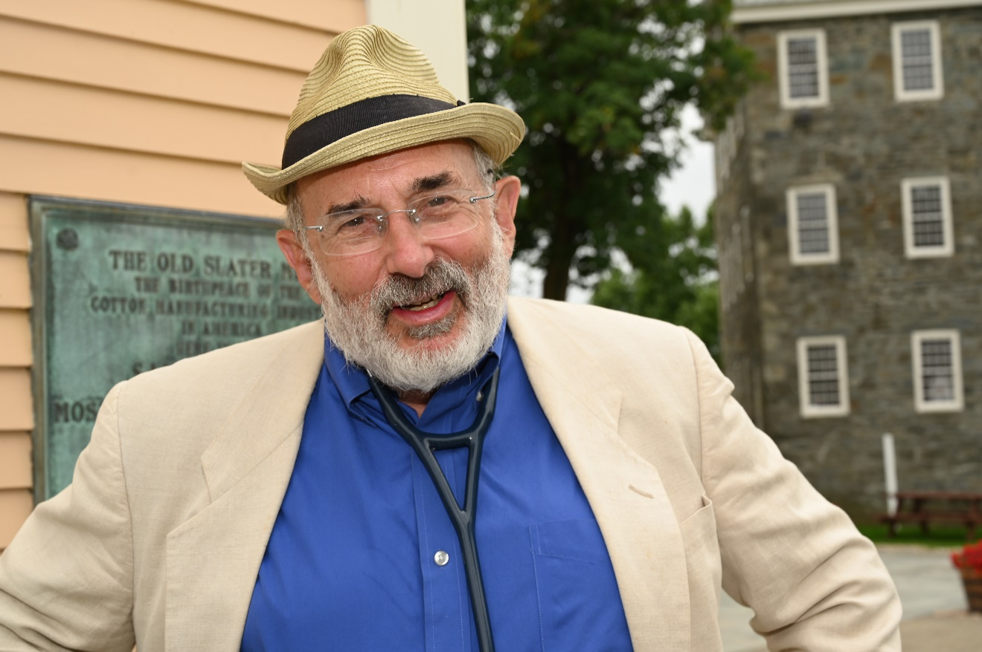

Michael Fine, MD is an award-winning author, community organizer, and family physician.

Fine is President and Board Chair of Primary Care for All Americans (www.primarycareforallamericans.org), an organization devoted to building a social movement to develop a health care system for the US that is for people, not for profit, and he serves as Chief Health Strategist for the City of Central Falls Rhode Island.
Fine is the author of The Jewish Prince of Denmark and Other Stories (Stillwater River Press, 2024), a collection of short stories about small choices, small acts, small ideas, simple decencies, the way people and a people take care of one another, people who live in the shadow of the valley of death but persevere; On Medicine as Colonialism (PM Press 2023), a meticulously researched book about how medicine and health care have become tools of a new health colonialism causing individuals and communities to loose their autonomy; Health Care Revolt, an expose, manifesto and playbook that exposes the failures of the health care market to deliver health and plans a movement to build the health care system the US needs (PM Press, 2018); Abundance, a novel about two young Americans caught up in the Liberian civil wars of 1998-2003 (PM Press, April 2019) The Bull and Other Stories (Stillwater River Press, 2020) and Rhode Island Stories (Stillwater River Press, 2021). He is the coauthor, with James W. Peters, of The Nature of Health (Radcliffe, 2007), a study of healthcare services, human rights, society, technology, and industry; and The Zero Calorie Diet (Red House Press, 2010), a look at the culture of excess through the lens of fasting. The Bull and Other Stories was the 2021 IPNE Literary Fiction Book of the Year.

Fine’s short stories have been published monthly on RINewsToday.com since 2018.

Dr. Fine served in the Cabinet of Governor Lincoln Chafee as Director of the Rhode Island Department of Health 2011-2015, overseeing a broad range of public health programs and services, 450 public health professionals and managing a budget of $110 million a year.
Dr. Fine’s career as both a family physician and manager in the field of healthcare has been devoted to healthcare reform and the care of underserved populations. Before his confirmation as Director of Health, Dr. Fine was the Medical Program Director at the Rhode Island Department of Corrections, with a healthcare unit serving 20,000 people a year and a staff of over 85 physicians, psychiatrists, mental health workers, nurses, and other health professionals. He was a founder and Managing Director of HealthAccessRI, the nation’s first statewide direct primary care organization, which made prepaid primary care available to people without employer-provided health insurance.

Dr. Fine practiced for 16 years in urban Pawtucket, Rhode Island and rural Scituate, Rhode Island. He was the Physician Operating Officer of Hillside Avenue Family and Community Medicine, the largest family practice in Rhode Island, and was Physician-in-Chief of the Rhode Island and Miriam Hospitals’ Departments of Family and Community Medicine. He was co-chair of the Allied Advocacy Group for Integrated Primary Care. He convened and facilitated the Primary Care Leadership Council, a statewide organization that represented 75 percent of Rhode Island’s primary care physicians and practices. He currently serves on the boards of the Lown Institute, and the Scituate Health Alliance.

Dr. Fine helped found the Scituate Health Alliance, a community-based, population-focused non-profit organization, which made Scituate the first community in the United States to provide primary medical and dental care to all town residents. Dr. Fine is a past President of the Rhode Island Academy of Family Physicians and was an Open Society Institute/George Soros Fellow in Medicine as a Profession from 2000 to 2002. He has served on a number of legislative committees for the Rhode Island General Assembly, has chaired the Primary Care Advisory Committee for the Rhode Island Department of Health, and sat on both the Urban Family Medicine Task Force of the American Academy of Family Physicians and the National Advisory Council to the National Health Services Corps. He is the recipient of many honors and awards, and has been inducted into the Pawtucket, Rhode Island Hall of Fame.

Dr. Fine’s career prior to and just after becoming a physician shaped his view of community healthcare. His early professional experience included jobs as a printer, a metal worker, a New York City taxi driver, and a VISTA volunteer and community health organizer in the South Bronx. As a National Health Services Corps Scholar in the mid 1980s, Fine worked for three years in rural Tennessee, in the fifth poorest county in America. In that community, with an illiteracy rate of 60 percent, he experienced the inextricable link between education and health, income and health, and health care and local economic development.

Dr. Fine lives in Scituate, Rhode Island with his wife Carol Levitt, also a family physician.

